Network Cabling Lab Session

What is a Network Medium?

In networking, a network medium is the physical material or wireless method used to transmit data between devices in a network.

🔌 Types of Network Media

Network media are broadly categorized into two types:

1. 📦 Wired Media (Guided Media)

Data travels through physical cables.

| Type | Description | Speed | Use Cases |
| --- | --- | --- | --- |
| Twisted Pair Cable | Pairs of wires twisted together to reduce interference. Comes in UTP and STP varieties. | Up to 10 Gbps (Cat6a) | LAN, Ethernet |
| Coaxial Cable | Single copper core with shielding. | Up to 10 Mbps – 1 Gbps | Cable TV, legacy networks |
| Fiber Optic Cable | Uses light to transmit data. Immune to EMI. | 1 Gbps – 100+ Gbps | Backbone, long distance, ISPs |

2. 📡 Wireless Media (Unguided Media)

Data travels through air or space via electromagnetic waves.

| Type | Description | Frequency | Use Cases |
| --- | --- | --- | --- |
| Radio Waves | Used for Wi-Fi and broadcast communication. | 2.4 GHz, 5 GHz | WLAN, IoT |
| Microwaves | Used in point-to-point communication. | GHz range | Satellite, microwave links |
| Infrared | Short-range wireless; line-of-sight required. | <1 THz | Remote controls, indoor use |
| Satellite | Long-distance communication via orbiting satellites. | Varies | Remote area internet |

⚙️ Comparison Table

| Medium | Speed | Distance | Cost | Interference | Security |
| --- | --- | --- | --- | --- | --- |
| Twisted Pair | Up to 10 Gbps | 100 m | Low | Moderate | Moderate |
| Coaxial Cable | Up to 1 Gbps | 500 m | Medium | Low | Moderate |
| Fiber Optic | 100+ Gbps | 10+ km | High | Very Low | High |
| Wi-Fi | 600 Mbps – 10 Gbps | ~100 m (indoor) | Low | High | Low – Moderate |
| Satellite | 100 Mbps+ | Global | Very High | High (latency) | Moderate |

What is IEEE in Networking?

IEEE stands for the Institute of Electrical and Electronics Engineers — a global organization that develops and maintains technical standards, including many that are crucial to computer networking.

In networking, IEEE standards define how devices communicate, connect, and maintain interoperability, especially for LANs (Local Area Networks), WANs, wireless, and data transmission protocols.

🌐 Common IEEE Standards in Networking

Here are some of the most important IEEE standards you should know:

1. 📡 IEEE 802 Family — Local and Metropolitan Area Networks

This is the most relevant group of networking standards, and includes:

| Standard | Description | Use Case |
| --- | --- | --- |
| IEEE 802.3 | Ethernet (wired LAN) | LANs using twisted pair/fiber optic |
| IEEE 802.11 | Wireless LAN (Wi-Fi) | WLANs in homes, campuses, offices |

2. 🔌 IEEE 802.3 (Ethernet) — Wired LAN

Defines how data is transmitted over twisted-pair and fiber optic cables.

| Subtype | Description |
| --- | --- |
| 802.3u | Fast Ethernet (100 Mbps) |
| 802.3ab | Gigabit Ethernet (1 Gbps over copper) |
| 802.3z | Gigabit Ethernet (1 Gbps over fiber) |
| 802.3ae | 10 Gigabit Ethernet |
| 802.3bt | Power over Ethernet (PoE++) |

3. 📶 IEEE 802.11 (Wi-Fi) — Wireless LAN

Defines the physical and data link layers for Wi-Fi standards.

| Standard | Speed | Frequency | Common Use |
| --- | --- | --- | --- |
| 802.11a | 54 Mbps | 5 GHz | Obsolete |
| 802.11b | 11 Mbps | 2.4 GHz | Obsolete |
| 802.11g | 54 Mbps | 2.4 GHz | Old home networks |
| 802.11n | 600 Mbps | 2.4 / 5 GHz | Common in offices |
| 802.11ac | 1+ Gbps | 5 GHz | High-speed Wi-Fi |
| 802.11ax (Wi-Fi 6/6E) | Up to 9.6 Gbps | 2.4 / 5 / 6 GHz | Modern networks |

4. IEEE 802.1 — LAN Bridging and Network Management

* 802.1D: Spanning Tree Protocol (STP)
* 802.1Q: VLAN tagging
* 802.1X: Port-based Network Access Control (used in enterprise authentication like WPA2-Enterprise)

Summary: Why IEEE Matters in Networking

* Ensures interoperability across different vendors and devices
* Defines standards for Ethernet, Wi-Fi, VLANs, and wireless personal networks
* Supports secure and efficient communication

*Hands-on Training for Structured Cabling and Network Setup*

1. Learning Objectives

* Understand the types of network cables and their applications.
* Learn how to terminate Ethernet cables (RJ45).
* Perform proper cable testing and troubleshooting.
* Gain hands-on experience with structured cabling setup.

2. Introduction to Network Cabling

* What is network cabling?
* Types of network cables:
  + Copper Cables: Cat5e, Cat6, Cat6a, Cat7.
  + Fiber Optic Cables: Single-mode, multi-mode.
* Importance of structured cabling.

3. Tools Required

* Cable crimper.
* RJ45 connectors.
* Cable tester.
* Wire stripper.
* Punch-down tool (for patch panels).
* Keystone jacks and faceplates.
* Patch cords.

4. Ethernet Cable Standards

* TIA/EIA Standards:
  + T568A vs. T568B wiring standards.
  + Explanation of color codes and pin assignments.
* Use cases for straight-through and crossover cables.

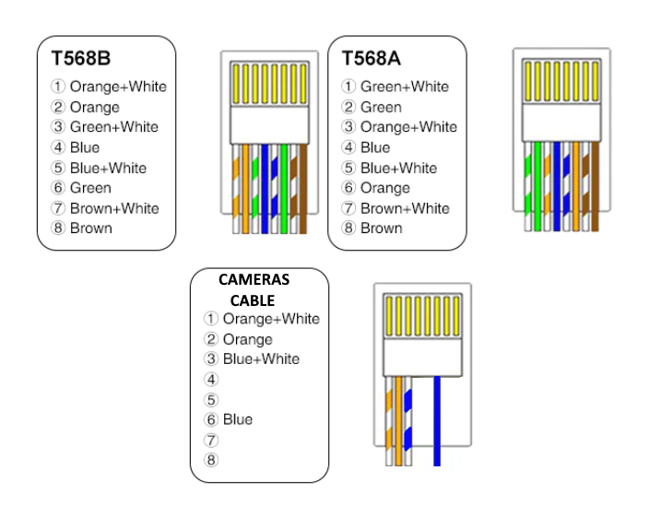

5. Step-by-Step Cabling Process

* Cutting and Stripping the Cable:
  + Properly prepare the twisted pair cable.
* Arranging the Wires:
  + Match the correct sequence for T568A or T568B.
* Crimping the Connector:
  + Secure the wires into the RJ45 connector.
* Testing the Cable:
  + Using a cable tester to verify connections.

6. Hands-On Activity

* Activity 1: Terminate a Cat6 Ethernet cable using T568B standard.
* Activity 2: Test the terminated cable with a network cable tester.
* Activity 3: Set up a simple LAN using patch cords, switches, and patch panels.

7. Troubleshooting Tips

* Common cabling issues:
  + Loose connections.
  + Incorrect wiring sequence.
  + Damaged cables.
* How to resolve these issues:
  + Reseat connectors.
  + Re-crimp cables.

8. Safety Precautions

* Handle tools carefully.
* Avoid over-bending cables.
* Ensure proper insulation of cables.